SAFETY RISKS IN APPLYING DAMAGE TOLERANCE ANALYSIS
TO CERTIFICATION OF ADHESIVELY BONDED STRUCTURES AND JOINTS
By
Maxwell Davis PSM, B.Eng (Mech.), M. Eng (Mech.), RPEQ
Director, Adhesion Associates Pty. Ltd.
Aircraft Airworthiness and Sustainment Conference, Brisbane, 26-28 July 2011.
ABSTRACT
For some considerable time, Damage Tolerance Analysis (DTA) has been an effective tool for management of airworthiness of aircraft structures. In essence, DTA relies on demonstration of continuing structural integrity in the presence of a defect of a known, detectable size, and then relying on post-production Non-Destructive Inspection (NDI) to eliminate components with unacceptable defects. Continuing airworthiness is then managed by a safety-by-inspection program using NDI to detect service defects before they exceed the tolerable defect size determined by the certification program. While such an approach has a history of being an effective tool for management of continuing airworthiness for cracks in metallic structures, there remain significant risks in application of the concept to adhesively bonded structural joints.
The most common form of testing to demonstrate structural integrity of bonded joints relies on strength tests during certification programs in the presence of embedded artificial disbonds of a known size. Finite Element Analysis may also be used to assess defects of a specific size in critical locations. Such tests and analyses infer that the adhesive bond surrounding the defect maintains its original strength. However, there are a number of common bond conditions which can result in significant degradation of bond strength over significant regions of the bond adjacent to such disbonds. Hence, the certification basis on which the tolerable defects size was determined has been compromised by changes in bond integrity in service, with a consequential risk to flight safety.
These specific bond conditions often pass post-production NDI and can not be detected in service by NDI until after partial or complete disbonding has occurred. The author contends that the application of DTA to structures which experience these types of defects may be inappropriate and may lead to a significant risk to flight safety.
Because all of these defects are due to production or repair process deficiencies or inappropriate repair methods, the author recommends that production and repair conditions and processes are managed to eliminate the causes of these defects during bonding processes. Only then will the application of DTA be appropriate for management of airworthiness of bonded structures.
INTRODUCTION
Damage Tolerance Analysis (DTA) is a proven and effective tool for management of continuing airworthiness of metallic structures. Damage tolerance is mandated by FARs 2X.573. Typical requirements are that the structure can sustain adequate loads in the presence of the defect and that the defect is detectable using appropriate and available NDI methods. This approach to testing carries with it the implied assumption that the structural material surrounding the defect maintains the original virginal strength and crack propagation properties. In some service circumstances, such as overheat damage to metallic structures which may alter the heat treatment of the alloy, the original DTA certification basis for the structure may be invalid.
For some considerable time the principles of DTA have been utilised to assess the damage tolerance of adhesive bonded structures and joints. Tests are undertaken during certification to demonstrate structural integrity of the component in the presence of known artificial defects, usually release film inserts.
The application of DTA to an adhesive bond is appropriate for validation of the residual strength of bonded structures at the time of production. Testing and/or analysis may determine the size of tolerable bondline defects and this data can be used to assess the acceptability of production defects, provided that the strength of the adhesive surrounding the defect matches the strength of the bonds used for certification testing.
This paper asserts that the deficiency in the DTA approach occurs when these results are translated to management of other defects which may occur in production, where production defects are repaired using ineffective methods and to defects which occur in later service. This assertion is based on the significant disparity between the bond strength at the time of certification and the strength of the bond under different circumstances. In an adhesive bond the properties may be degraded by certain production and service conditions to an extent that failure may occur in the absence of a detectable defect, and hence the application of DTA is invalid.
DEFINING THE PROBLEM
There are at least four production or repair based problems which:
- May not be detectable using post-process NDI, and
- May result in significant reduction of bond strength that in some cases may not be confined to regions within the in-service defect region.
These problem issues are:
- Bond strength reduction due to interfacial degradation in service, leading to adhesion or mixed-mode failure,
- Interfacial inadequacy due to poor heat distribution during repair bonding, leading to adhesion failure,
- Micro-voiding of the adhesive material, leading to cohesion failure, and
- Injection repair of production and service disbonds.
Examples will be presented of actual bond failures of components to demonstrate that reliance on DTA for adhesive bonded structures may be inappropriate. At least one example probably resulted in loss of the aircraft, and other examples have led to unanticipated in-flight component failures.
ADHESIVE BONDING MECHANISMS
To understand how adhesive bonds fail, it is necessary to understand the mechanisms of how adhesive bonds actually work. There is a common misconception that adhesive bonds rely on mechanical interlock, which is why surfaces are roughened or etched before bonding. This is not the case. Structural adhesive bonds rely on chemical bonds formed at the interface, a process which is termed “adsorption” []. These bonds are typically covalent but may also involve ionic and electrostatic attraction bonds.
Understanding that adhesive bonds depend upon chemical reactions at the interface also explains the necessary conditions for formation of those bonds. The surfaces must firstly be clean, so that chemical reactions can occur. Next, the surface must be chemically active so that reactions can occur such that adequate chemical bonds are formed to provide adhesive bond strength. If these conditions are met, then it is possible to generate bond strength at least in the short term.
The continuing strength of an adhesive bond for metallic surfaces depends to a limited extent upon maintaining the properties of the adhesive layer. The properties of the adhesive material do degrade slightly due to absorption of atmospheric moisture, but this is usually taken into account by characterising the adhesive properties after moisture conditioning of specimens, or applying a knock-down factor to the adhesive properties for design purposes.
However bond performance depends far more strongly on maintaining the integrity of the chemical bonds at the interface between the adhesive and the substrate. If the interfacial bonds are compromised, then adhesion failure will eventually occur, even without the application of flight loads and irrespective of the level of conservatism in the design.
NDI OF ADHESIVE BONDS
Fundamental to the application of DTA to adhesive bonds is the existence of effective means for detecting the presence and size of bond defects, and this usually relies on NDI. A number of inspection methods are available including ultrasonics, holography and thermography. All of these methods depend directly on detecting air gaps in the bond-line, and therefore they can only find a defect after disbonding has occurred. As will be discussed, the strength and durability of adhesive bonds is highly dependent on the integrity of the interface between the adhesive and the adherends. There is no current NDI method which can interrogate the condition of the interface, hence there is no method to provide assurance of ongoing airworthiness of an adhesive bond. NDI can readily detect bond defects which involve air gaps but it can not guarantee that the interface between the adhesive and the adherend is effective.
ADHESIVE BOND FAILURE TYPES
While there are many causes of adhesive bond failures, there are essentially only three types of bond failure:
- Cohesion failure where the adhesive layer is fractured,
- Adhesion failure where the adhesive layer separates from the surface of the adherend(s), and
- Mixed-mode failure which is a variable combination of adhesion and cohesion failure.
The features of these failure types and the implications to DTA will be discussed.
COHESION FAILURES
Cohesion failures are characterised by fracture of the adhesive layer, leaving residual adhesive on both adherend surfaces. Cohesion failures usually result from design issues such as poor management of thermal stresses, stiffness mismatch (thickness and elastic modulus) between adherends, inadequate bond overlap, or inappropriate selection of an adhesive with inadequate strength or an inadequate service temperature range. Normally, such occurrences would be eliminated as part of the certification test program, so the occurrence of cohesion failures in service should be rare and limited to overload events.
Typically, for film adhesive systems which use a carrier cloth, failure will progress through the plane of the carrier cloth in cohesion failures because that is the weakest plane for the adhesive layer (see Figure 1).
Failure Due to the Presence of Voids in the Adhesive Bond
More commonly, cohesion failure may result from the presence of bond-line defects. There are essentially two types of bond line voids; large voids termed “macro-voids” and small, widely distributed voids, termed “micro-voids”.
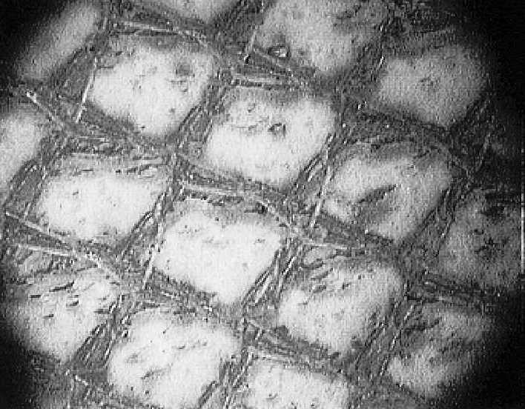
Figure 1. The surface of an effective adhesive bond which has failed by cohesion. The mesh pattern shown is the carrier cloth which has a pitch of 0.5mm (0.020 in.)
Macro-voids
Macro-voids (see Figure 2) may reduce the available bond length below acceptable requirements to sustain the applied load, such that failure of the remaining adhesive occurs as cohesion failure. Normally one would expect that many of these defects would be eliminated by the certification testing program and post-production NDI. These defects are often “repaired” by injection of a paste adhesive, as discussed in Injection Repair of Voids and Disbonds. It must be stressed that voids such as those shown in Figure 2 only occur during production. There is no mechanism for these voids to occur during in-service operation of the component.
Application of DTA to Macro-Voids
Provided that the adhesive material surrounding macro-voids is of a high quality, then the application of DTA is an appropriate and effective method for managing airworthiness.
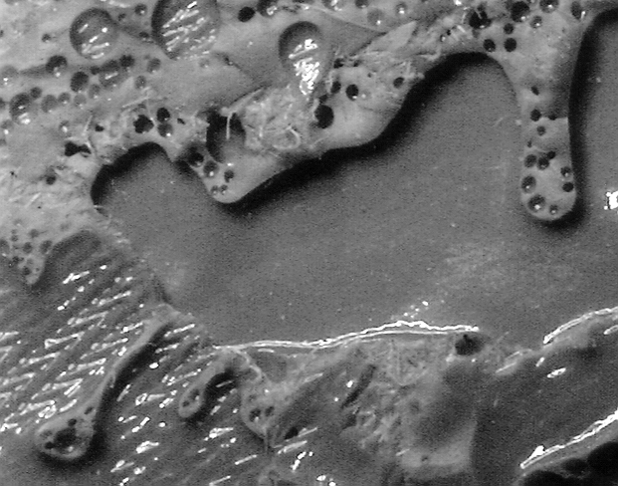
Cohesion failure
Macro-voiding
Figure 2. The surface of an adhesive bond which has failed by cohesion due to macro-voiding. The mesh pattern in the lower left of the picture is the carrier cloth which has a pitch of 0.5mm (0.020 in.)
Micro-Voids
Micro-voids are voids which are typically smaller than the mesh of the carrier cloth (see Figure 3). Micro-voiding occurs as a result of absorption of atmospheric moisture by the adhesive prior to the production cure cycle. That moisture is evolved at elevated temperatures resulting in the formation of multiple small voids, which tend to be constrained by the mesh of the carrier cloth. The problem with micro-voiding is that even bonds which are severely micro-voided may pass NDI because there is sufficient contact to pass sound waves, even though the strength of the bond is almost certainly reduced. Because of the small size of the defects (well below the critical defect size as determined by DTA) there has been a tendency to ignore the presence of micro-voiding. While each void may not be of a significant size, in cases where there are multiple voids, the total size of the voided area may exceed the tolerable defects size as determined by DTA, resulting in a significant loss of bond strength.
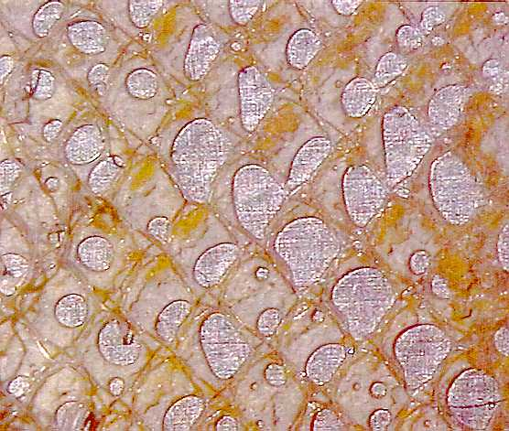
Figure 3. The surface of an adhesive bond which has failed by cohesion due to micro-voiding. The mesh pattern shown is the carrier cloth which has a pitch of 0.5mm (0.020 in.)
The only reliable method for detection of micro-voiding is by visual inspection of the adhesive flow at the edge of the bond. The presence of a large number of bubbles is a strong indicator of the presence of micro-voids.
There is a common perception that such voids are removed by application of vacuum during the cure cycle. This is not the case. Only in the edges of the joint can vacuum draw out volatiles, but away from the edges of the joint the low pressure caused by high vacuum actually causes the void size to increase, causing adhesive to displace from the joint and resulting in increased micro-voiding.
In one study [] exposure of FM300 adhesive to an environment of 30°C (86°F) and 70% RH for four hours resulted in a loss of 53% in T-Peel strength for ASTM D1876 specimens and honeycomb peel strength for ASTM D1781 fell by 28%. Other reference material indicates that shear strength may also be reduced []. Environmental conditions such as these regularly occur in many production and repair facilities worldwide, therefore the strength of a structure fabricated in an uncontrolled environment will depend directly on the temperature of the day combined with the occurrence of high humidity.
Reductions in bond strength of the significance attributed in Reference [Error: Reference source not found] to micro-voiding should be detected by QA tests on coupons at the time of manufacture. However because the standard QA strength test, the lap-shear test ASTM D1002, has an overlap length of only 12.7 mm (0.5 in.) this size is sufficiently small for the vacuum to draw out volatiles, leading to a falsely higher value for the coupon than that which would be derived in the larger bond surfaces in the actual structure.
The author discussed this issue with one helicopter manufacturer who operated a major bonding facility located in semi-desert environment with an annual rainfall less than 200 mm (8 in.). An example of a bond failure in one of their products which exhibited micro-voiding was presented (see Figure 4). (It must be stressed that the micro-voiding was not the cause of the flight incident in this particular example.) A comparison of production records and rainfall records showed a direct correlation between the presence of micro-voiding and the occurrence of rain recorded on the specific day the component was manufactured. If this occurred in a facility which usually has a dry “desert” environment, how much more significant is this type of strength loss for facilities where days of high humidity are more common?
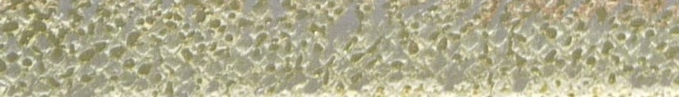
Figure 4. Micro-voiding in an adhesive bonded joint from a crashed component. The darker grey regions are micro-voids. The mesh pattern shown is the carrier cloth which has a pitch of 0.5mm (0.020 in.)
In this example, the manufacturer had a tolerable defect size established from strength tests, but the total size of the micro-voids located on any given line along the bond length has the potential to exceed that tolerable defect size, almost certainly resulting in an inadequate residual overlap length to sustain certification loads, and potentially below the overlap length necessary to sustain limit loads.
In another example, the photographs of the adhesive bonds in Figure 5 were taken after a section of tail-boom skin on another type of helicopter disbonded in service and was removed during repair. These examples clearly exhibit extensive micro-voiding. Careful examination of the bonds between the core and the skin shows that not only are micro-voids occurring in the cell area of the bond, they are also occurring in the fillet area formed between the adhesive and the core. The fillet between core and adhesive is critical to attainment of bond strength in sandwich structure. The reduced bond area caused by these micro-voids has the potential to significantly reduce the shear strength and flatwise tensile strength of the honeycomb bonded structure, so there is a strong possibility that the micro-voiding was either the cause or a major contributing factor which resulted in these disbonds.
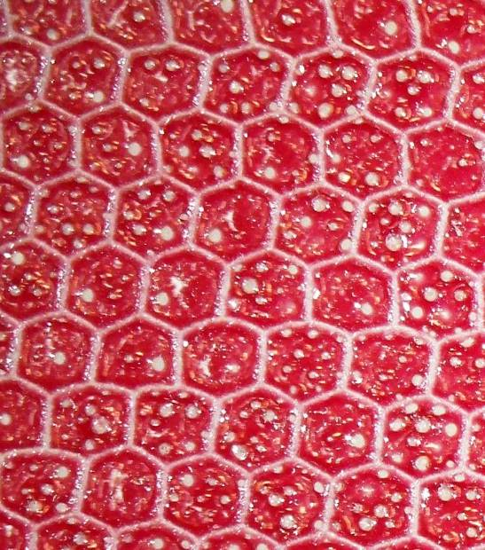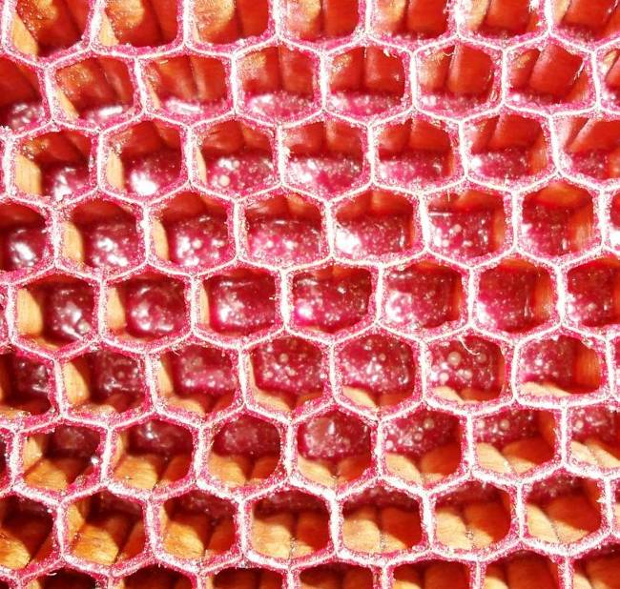
Figure 5. Photographs of a disbonded area cut from a helicopter tail boom structure showing extensive micro-voiding. The skin side is shown on the left and the view of the core is shown on the right.
There has been one case reported where this structure failed during ground operations. The manufacturer attributed the failure to “undisclosed damage” from a previous tail strike, despite the fact that their own report contained images which clearly exhibited similar micro-voiding in the disbonds shown in Figure 5.
The core in this example is Nomex™ and that particular material also absorbs atmospheric moisture which is released by elevated temperature curing of the adhesive layer and adds to the micro-voiding problem. The author has personally measured moisture contents exceeding 4% by weight for Nomex™ specimens. Unless this type of core is thoroughly dried immediately prior to the bonding process, that moisture will be evolved during elevated temperature cure, leading to further micro-voiding.
In this particular example, the manufacturer has relied on DTA by Finite Element Analysis (FEA) to show that presence of such disbonds is not critical to flight safety. Irrespective of assignment of causal links, the fact remains that the strength of the bond is substantially compromised by the presence of micro-voiding and hence the strength of the bond is below the strength of the bond which would have been used for certification. FEA adhesive property data is usually determined from laboratory tests which are often undertaken on specimens produced in controlled environments. Unless the FEA was performed with adhesive allowable strength values reduced to take into account the loss of shear and tensile strength caused by micro-voiding in the production environment, then the level of confidence in the DTA assessment of flight safety must be seriously questioned.
The Significance of Micro-voiding
Suppose that an article was qualified and certified in a naturally dry environment without any control of temperature or humidity, and produced a structure which failed at 150% of Design Limit Load (DLL). Next, suppose production was outsourced to “Gybrobia”, where the environment was 30°C (86°F) and 70% RH. According to Reference [Error: Reference source not found] there is a 28% reduction in honeycomb peel strength and a 53% decrease in T-Peel. How does this translate to flight safety?
For honeycomb peel:
$$\begin{aligned}\text{Strength}=1\text{.}5×\text{DLL}×0\text{.}\text{72} \\ =1\text{.}\text{08}×\text{DLL}\end{aligned}$$
For T-Peel:
$$\begin{aligned}\text{Strength}=1\text{.}5×\text{DLL}×0\text{.}\text{47} \\ =0\text{.}\text{705}×\text{DLL}\end{aligned}$$
Hence, the design is marginal at Limit Load for honeycomb peel and unconservative for peel in joints (T-Peel). Obviously, use of the original peel strength values for DTA would be a risk to flight safety.
Managing Micro-voiding
Micro-voiding is caused by moisture being absorbed by the adhesive prior to an elevated temperature cure cycle. There are numerous sources of moisture which need to be addressed as part of a quality management system for adhesive bonded structures. These causes and preventative measures have been collated by Adhesion Associates Pty. Ltd. and are available on the internet [].
Although the FAA Advisory Circular AC 20-107B provides extensive guidance on management of contamination at all stages of materials acceptance, handling, storage and use, the AC states at para 6.b.(1) that:
“The environment and cleanliness of facilities are controlled to a level validated by qualification and proof of structure testing.”
This advice is often interpreted thus: Provided the component passes qualification and certification when fabricated in a facility with minimal (or no) environmental controls, then it is acceptable to manufacture components in facilities with a similar minimal level of environmental controls. Such an interpretation of the guidance carries a great risk to flight safety. If as in the case shown in Figure 4 and 5, the manufacture of specimens for qualification and components for certification testing had been performed in an environment with no air conditioning and/or no humidity control during periods when the environment was dry, then a good result would be achieved. In contrast if high humidity occurs during production then the strength of the component produced may be significantly reduced.
The current practice of out-sourcing production around the world as part of globalisation may carry a risk if the production environmental humidity and temperatures differ greatly from those for the environment used to manufacture the certification articles.
Conclusion in relation to micro-voiding
DTA of adhesively bonded structures which are manufactured in environments where they are susceptible to moisture absorption is inappropriate unless the allowable strength values reflect the loss of strength caused by micro-voiding.
Recommendation
Surely it would be far more prudent to mandate that composite and adhesive qualification, certification and production processes where uncured material is exposed to a potentially humid environment must be standardised to controlled levels where experience has shown that micro-voiding due to moisture absorption by uncured adhesive materials is minimised? Data on these conditions is available [Error: Reference source not found].
ADHESION FAILURES
Adhesion failures are characterised by the absence at any location of adhesive material from one surface of the adherends. In other words, the failure has progressed through one of the interfacial zones of the adhesive bond (see Figure 6).
There are three basic causes of adhesion failures:
- Contamination during the bonding process,
- Degradation of the chemical bonds at the interface during service, or
- Inadequate heat distribution during elevated temperature curing of the adhesive bond for repair.
Contaminated bonds
Contaminated bonds would normally be detected by post-production QA testing, provided that the rejection criteria are set at an appropriate level of strength. Contamination may or may not produce defects which are detectable using post-production NDI.
Interfacial degradation
Susceptibility of adhesive bonds to interfacial degradation leading to adhesion failures depends directly on the integrity of the chemical bonds at the interface formed at the time of cure of the adhesive bond. If these chemical bonds are susceptible to degradation in service, then what starts out as an initially strong adhesive bond may in later service degenerate to a weak adhesive bond. In bonds formed between metallic adherends, the most common form of degradation is by hydration of the oxides on the surface of metallic adherends [, , ]. As the oxides on the surface of the metal hydrate, the chemical bonds between the adhesive and the adherends may dissociate leading to interfacial adhesion failure.
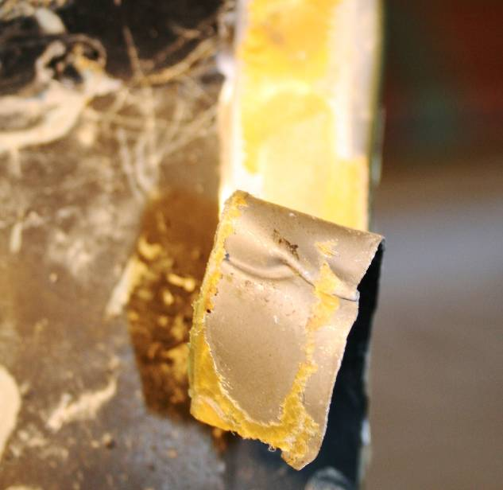
No Adhesive
Adhesive disbonded from other surface
Figure 6. The failure surface of an adhesive bond after adhesion failure.
The classic example is for bonds to aluminium surfaces. As part of the production process, the thicker surface oxides are usually removed by chemical processes such as etching or by mechanical processes such as grit-blasting. Aluminium almost instantaneously oxidises to form Al₂O₃. However, aluminium has an affinity for the formation of a hydrated oxide bohemite Al₂O₃.2H₂O. The levels due to absorbed atmospheric moisture in typical adhesive types are sufficient to promote hydration of the interface, leading to dissociation of the interfacial chemical bonds so that hydration can occur over time and the consequence is adhesion failure. There is a considerable loss of bond strength compared to the strength immediately after manufacture, and disbonding may occur even without flight loads (see [] for example).
Adhesion Failure Due to Inadequate Heating During Repair
A lesser known cause of adhesion failures occurs due to an inadequate distribution of temperature during the adhesive cure cycle for bonded repairs. This may occur also due to cold spots in moulds or poor air circulation in autoclaves. In such cases, slow heating results in the adhesive material cross-linking and becoming rigid before it has had a chance to wet the surface of the adherend and form chemical bonds with the adherend that are necessary for the development of bond strength. The effect is similar to that which would result from the use of out-of-life material.
Figure 7 shows an example of a bonded repair to complex structure. The repair covered an area of thin aluminium skin fastened in a thicker region to a heavy frame section. The technician used a single heater blanket to cure the repair. In the regions where the skin was thin the adhesive failed by cohesion when the repair was removed following a negative in-service NDI inspection. In that area, the temperature profile experienced by the adhesive layer was sufficient to provide adequate cure of the adhesive. However, in the region where the repair was located over the thicker frame structure, the adhesive failed in an adhesion mode. In that area, the temperature profile experienced by the adhesive layer resulted in a slow heat-up rate and a failure to achieve cure temperature, resulting in the adhesive curing without flowing and wetting the surface. Adequate chemical bonds between the adhesive and the adherends could not be formed. For repairs, it is essential to ensure that the distribution of separately controlled heat sources matches the thermal mass distribution of the structure, (see []).
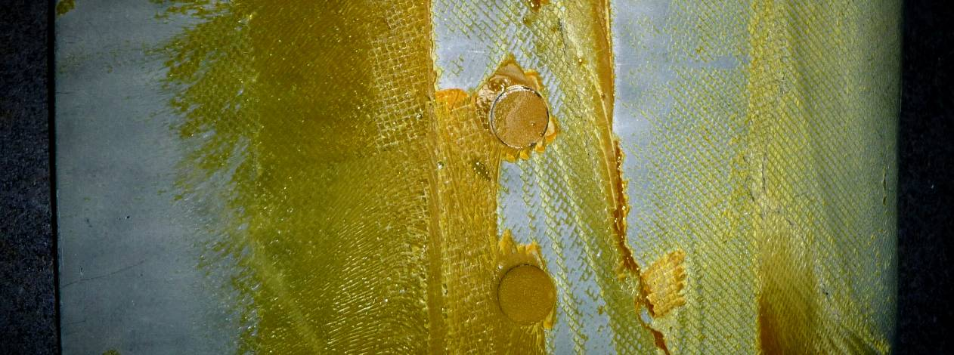
(a)
(b)
Figure 7. A photograph of an adhesive bonded repair after removal displaying (a) cohesion failure where the section of the repair over thin skin was correctly heated, and (b) adhesion failure where the thick underlying structure caused a slow heat-up rate.
MIXED-MODE FAILURE
Mixed-mode failure occurs as a combination of both cohesion and adhesion failures, and typically occurs in a plane at or near the interface (see Figure 8). Note that the areas of adhesion failure in Figure 8 exhibit total separation of the adhesive from the adherend, while some of the adhesive has fractured in the area of mixed-mode failure. Note also that in the area of mixed-mode failure the failure did not occur through the plane of the carrier cloth.
In essence, a mixed-mode failure occurs at an interface where an adhesion failure would have eventually occurred had the component not experienced loads of a sufficient magnitude to cause failure before the interface had fully degraded.
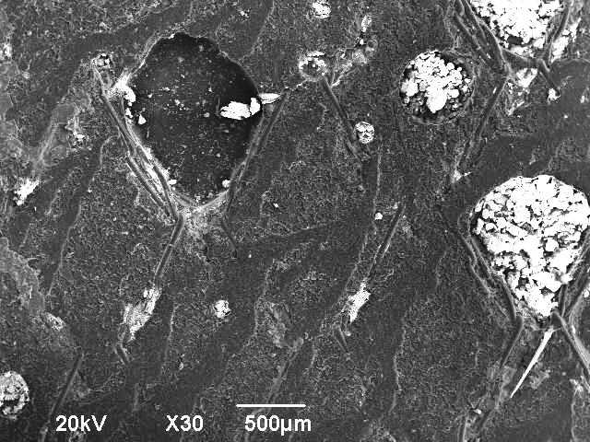
Mixed-mode failure
Adhesion failure
Figure 8. Adhesion and mixed-mode failure in an adhesive bond from a crashed helicopter.
It must be stressed that although mixed-mode failure may result in traces of adhesive on the surface of the adherends, failure will occur at a considerably lower strength than for a cohesion failure. This type of failure is often misinterpreted by safety investigators who incorrectly identify the presence of even the smallest layer of adhesive on a surface as being a cohesion failure, which implies that the bond exhibited adequate strength when in fact the strength of the bond may be severely degraded.
Explaining Mixed-Mode Failure
Mixed-mode failure is a direct result of degradation of the interface between the adhesive and the adherend. As the interface degrades, the plane of failure shifts [Error: Reference source not found] from the plane of the carrier cloth (cohesion failure) towards the interface (adhesion failure) (see Figure 9). The bond strength also degrades as the proportion of adhesion failure increases. In effect, the closer the failure occurs to the interface, the lower the strength of the adhesive bond. Hence, it is important to understand that the presence of a thin film of adhesive on a failure surface is not proof of a high-strength cohesion failure, and in fact may be evidence of a low strength mixed-mode failure.
Figure 10 provides a schematic representation of the effect of interfacial degradation on bond strength over time. An effective adhesive bond with no interfacial degradation is shown at Line A. There is a slight reduction in strength over time as the adhesive becomes moisture conditioned. This reduction in strength is well known and easily managed by design and certification using moisture conditioned adhesive properties.
In contrast, Line B shows an approximation of how bond strength may decay with time as the interface degrades []. If such a bond were tested soon after manufacture (Line 1), minimal hydration has occurred and the strength exceeds the design requirement. After longer term exposure (Line 3), the strength of the bond decays until complete interfacial failure occurs at a significantly reduced strength. In between these points (Line 2) mixed-mode failure occurs at a level of strength somewhere between the other two values.
Figure 9. Model explaining how the progression of interfacial degradation changes the locus of failure of an adhesive bond and reduces bond strength.
Figure 10. A schematic representation showing the transition from strong cohesion failure through weaker mixed-mode failure to weak adhesion failure due to interfacial degradation and the region where NDI can not detect insipient mixed-mode failure.
Of importance, the limitations of effectiveness of NDI are also shown in Figure 10. NDI can detect production voids and provided they are not injection repaired, it will find those voids over the life of the component. However for degrading bonds, NDI can only detect disbonds after they occur. For the largest proportion of the life of an adhesive bond, NDI is ineffective because it can not detect the onset of interfacial degradation. Interfacial degradation may manifest itself as a loss of bond strength without actually producing any disbond which could be detected by NDI, as shown in Figure 10, Line 2. Such failures would be predominantly mixed-mode failures. The major safety risk therefore is that the bond strength may have decayed to unacceptable levels before any defect can be detected by NDI.
Production NDI and QA of Structures which Later Exhibit Adhesion or Mixed-Mode Failures
After the bond has been produced with a process which results in short-term strength sufficient to pass Quality Assurance testing and post-production NDI, as shown in Figure 10, Line 1, it is concerning that the same bond process may result in interfacial degradation in later service as shown in Figure 10, Line 2 or Line 3.
Where the bond has been processed using a slow heat-up rate, there is usually sufficient contact to enable sound waves to pass, so the component may pass NDI, even though the strength is deficient. If companion coupon specimens do not experience exactly the same cure cycle (because they are located in a more acceptable heat profile) then such components may escape detection during post-production evaluation.
Other Issues to be Considered in Mixed-Mode Failure Progression
The strength loss represented in Figure 10 is applicable for cases where the entire interface is degraded. In practical joints, the occurrence of hydration depends upon the availability of moisture [Error: Reference source not found]. All epoxies absorb atmospheric moisture by diffusion from exposed edges, and that diffusion follows Fick’s Law, such that the moisture level decays exponentially from the exposed edges. This explains why adhesion failure occurring at the edges of the bond in Figure 11 is accompanied by mixed-mode failure in the centre of the bond.
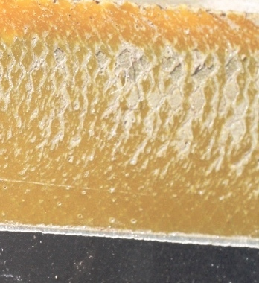
Mixed-mode failure
Adhesion failure
Figure 11. Adhesion and mixed-mode failure in an adhesive bond from a crashed helicopter.
A further complicating issue is the distribution of shear stress in an adhesive bond under shear and peel. There is a common perception that adhesive bonds are uniformly loaded (78% of manufacturers surveyed at an FAA Workshop in 2004 stated that they use an average shear stress design methodology []). In reality, the shear stress distribution in a bonded joint is non-uniform, with peaks at each end of the joint (see Figure 12).
This non-uniform stress distribution also occurs for peel stresses in bonded joints, with peaks also occurring at the ends of the joint. Hence, high shear and peel stresses occur at the edges of the joint, in the same region as moisture diffusion is highest and consequently hydration of the bond is most probable. In contrast, towards the centre of the joint, shear and peel stresses are substantially lower, the level of diffused moisture is lower, and consequently hydration is not as advanced.
Figure 12. Adhesive shear stress distribution in an adhesive bonded joint.
One outcome of this assessment is that long bond overlap lengths greatly enhance the survivability of bonded joints because there is sufficient un-degraded interface in a region of lower moisture diffusion such that some strength is retained by the joint. Failure by adhesion at the edges may occur while there is sufficient residual bond strength to sustain the required loads. In such cases, adhesion failures may be detected by NDI at the edges of the bond before overall mixed-mode bond failure occurs. Provided sufficient reserve bond overlap length exists such that a critical minimum bond length is not hydrated, the joint may provide sufficient strength to sustain the required loads and NDI may be appropriate for management of such bonds, provided that the hydration rate is sufficiently slow. However, DTA is only valid if the analysis is based on the reduced strength of the adhesive at the ends of the bond.
In contrast, for bonds with short overlap lengths (typical of some average shear stress designs) there is not sufficient reserve overlap length to enable the formation of complete adhesion failure disbonds before the entire bond strength degrades due to hydration over the short bond length and the strength falls below a critical value when catastrophic mixed-mode failure will almost certainly occur at a considerably lower load than that demonstrated during certification testing. In such cases, NDI and DTA are totally inappropriate for management of airworthiness because there may be no detectable defect prior to failure.
ARE THERE EXAMPLES OF ACCIDENTS DUE TO BOND DEGRADATION?
There are many examples of bond failures which have not resulted in loss of an aircraft. Adhesive bond failures are frequent in structures manufactured using processes which do not provide resistance to hydration. However, the identification of hard evidence of actual structural failures due to bond degradation at crash sites is intrinsically difficult because usually there is extensive secondary damage which in many cases produces similar failure modes. Unlike the characteristic features of fatigue cracking in metals, there is no clear tell-tale evidence to categorically link a particular feature with the cause of the event. The failure surface due to mixed-mode bond failure which causes a crash will be difficult to differentiate from mixed-mode failures caused by the forces experienced during the crash.
In many cases there is clear evidence (from the locus of failure in relation to the carrier cloth) that the bonds in a structure are undoubtedly weaker than the strength at the time of original manufacture, but there may be no clear evidence to show that the strength of the structure was sufficiently degraded to be the primary cause of failure (see Figure 11). Conversely however there is no clear evidence to show that the structure was strong enough to sustain flight loads. In such cases, assessment of the cause of failure may rely on circumstantial evidence [Error: Reference source not found] such as the location of parts in the debris path, eye witness reports or structural testing of identical parts which have experienced a similar service environment.
The final report of one such example is awaiting release by the relevant aviation authority.
Discussion on DTA and NDI for adhesion and mixed-mode failures
In practice, defects discovered in service by NDI which were not present post-production are either mixed-mode or adhesion failures or cohesion failure due to micro-voiding. Such defects will not be macro-voids.
The real concern for the application of DTA to structures which later experience adhesion failures or failure due to micro-voiding relates to the performance of these structures during service. If the tolerable defect size has been established by tests using artificial implanted defects and the surrounding structure maintains full strength and then a disbond (even if it is smaller than the tolerable defect size) is detected in service, there is no method to provide assurance that the combined effect of the disbond and the degradation of strength for the adhesive bond surrounding the defect to provide assurance that the structure maintains adequate structural integrity.
Unlike the use of fracture mechanics for prediction of crack growth rates in metals, there is no comparable methodology for prediction of disbond growth rates in adhesive bonds, especially for adhesion type failure modes. Hence, there is also no method for providing assurance that the defect will not continue to propagate to an extent where it may exceed the tolerable defect size within the next inspection interval.
OFFICIAL GUIDANCE
Regulations
The FAA provides regulation of adhesive bonded structures, but these regulations do not address bond durability. They require demonstration of static strength, fatigue and damage tolerance as well as mandating the use of processes which “are known to produce a sound structure”, combined with NDI or proof testing.
“For any bonded joint, § 23.573(a)(5) states in part: "the failure of which would result in catastrophic loss of the airplane, the limit load capacity must be substantiated by one of the following methods—(i) The maximum disbonds of each bonded joint consistent with the capability to withstand the loads in paragraph (a)(3) of this section must be determined by analysis, tests, or both. Disbonds of each bonded joint greater than this must be prevented by design features; or (ii) Proof testing must be conducted on each production article that will apply the critical limit design load to each critical bonded joint; or (iii) Repeatable and reliable non-destructive inspection techniques must be established that ensure the strength of each joint."
As has been shown in this paper, static strength and fatigue tests do not discriminate between structures which are resistant to in-service degradation and those which are susceptible. Damage Tolerance has been shown in this paper to be of limited value for anything other than production macro-voids, for which this approach is highly effective. However, early term proof testing and NDI can not discriminate against bonds which may fail in later service by interfacial degradation.
FAR 23.605 states:
“Fabrication methods.
(a) The methods of fabrication used must produce a consistently sound structure.”
The term “sound structure” is highly subjective. If a structure passes static strength and fatigue testing, has been shown to be damage tolerant and passes post-production NDI and QA testing, is it “sound”? The answer is NO unless the processes used have been shown to provide resistance to in-service degradation, and if the occurrence of micro-voiding has been mitigated by environmental control of bonding facilities to minimise exposure of adhesives to high humidity.
Formal Advice
The regulations are supported by an Advisory Circular AC 20-107B. Recent amendments to AC 20-107 to B status included a number of fundamental amendments. The first states
“Adhesion failures, which indicate the lack of chemical bonding between substrate and adhesive materials, are considered an unacceptable failure mode in all test types. Material or bond process problems that lead to adhesion failures are solved before proceeding with qualification tests.” Para 6.c.1.
This is supported by:
“Adhesion failures found in production require immediate action to identify the specific cause and isolate all affected parts and assemblies for disposition.” Para 6.c.4.
This advice is a positive step toward establishing airworthiness for adhesive bonded structures and is to be commended. Clearly, if adhesion failures occur in certification or production quality assurance tests, then the problem may degenerate further in service.
The occurrence of adhesion failures in service is also addressed:
“Adhesion failures discovered in service require immediate action to determine the cause, to isolate the affected aircraft, and to conduct directed inspection and repair. Depending on the suspected severity of the bonding problem, immediate action may be required to restore the affected aircraft to an airworthy condition.” Para 6.c.4.
Again, these measures are to be commended for addressing the most common cause of bond failures in service. However, the term “suspected severity” is again subjective. If the disbond detected is smaller than the tolerable defect size determined by testing of artificial defects in otherwise pristine adhesive bonds, is the component airworthy? The answer would depend upon the zone of influence of the interfacial degradation which caused the interfacial failure. If there is evidence of a production contamination (thumb print, included release material etc.) then the approach outlined above is valid. If however there is no clear evidence of a production contaminant, then it must be assumed that the adhesion failure is a direct result of interfacial degradation, and as such the zone of influence of the defect is indeterminate. Localised repair of such defects may leave a surrounding zone of partially degraded bond, with a consequent risk to airworthiness. Injection repair would leave an ineffective bond plus the surrounding zone of degradation, with an even greater risk to airworthiness.
Policy
The FAA has issued a policy statement PS-ACE100-2005-10038 []
“A wedge specimen that combines peel loads and extreme environmental conditions has proven to be a good accelerated lab test for detecting unacceptable metal bond processes, which degrade over time and lead to adhesion failures in service.”
Section 3. 1.
This is consistent with Recommendations for mixed-mode and adhesion failures in this paper.
Discussion on Guidance
It must be stated that it is possible within the current framework of guidance to actually produce reliable, durable adhesive bonds, provided that the policy at PS-ACE100-2005-10038 Section 3. 1 is implemented, or at least some form of equivalence is demonstrated prior to any certification testing or production. This must be combined with the advice at Para 6.c.1. and Para 6.c.4 of AC 20-107B to produce durable adhesive bonds. If these conditions are supported by FAR 23.573(a)(5) and FAR 23.605 then it is possible to construct durable adhesively bonded structures. However, continuing airworthiness must also address AC 20-107B Para 6.c.4 as a criterion for assessing adhesion failures.
It must be stated that, while it is possible to infer the roadmap for reliable, sound and durable adhesive bonds from the regulations, advice and policy documents currently available, this process is open to interpretations which may (and sometimes do) result in bonds with poor service durability and consequent risks to airworthiness which are not prevented by DTA.
This confusion could be avoided [] by the simple addition of the words “and durable” in FAR 23.605:
“Fabrication methods.
(a) The methods of fabrication used must produce a consistently sound and durable structure.”
HOW TO VALIDATE DTA FOR CONTINUING AIRWORTHINESS OF ADHESIVE BONDED STRUCTURES
It is possible to apply DTA to adhesive bonded structures with confidence, provided that several basic precautions are rigorously enforced. These measures are aimed at prevention of adhesion failures and prevention of micro-voiding during production.
Before any certification samples are produced, it is essential to demonstrate that the surface preparation process proposed is capable of producing adhesive bond interfaces which are resistant to hydration.
The best way to manage adhesion and mixed-mode failures is to prevent the occurrence of interfacial degradation in service. The resistance of the interface to hydration depends totally on the method used to prepare the surface for bonding. The most effective means of demonstrating resistance to hydration is the wedge test ASTM D3762 (see Figure 13) provided that the following acceptance criteria are used [Error: Reference source not found]:
- < 0.2 inches growth in 24 hrs testing,
- < 0.25 inches growth in 48 hrs testing, and
- < 10% adhesion failure in the test zone.
It should be noted that the acceptance criteria stated in ASTM D3762 para 10 are totally inadequate and would permit the use of processes which will certainly produce adhesion failures in service.
Figure 13. ASTM D3762 wedge tests for validation of hydration resistance of adhesive bonds for metal adherends.
If these conditions are met, service experience [Error: Reference source not found, , , ] has demonstrated that durable adhesive bonds can be manufactured so that hydration of the interface is prevented. Experience with such bonds for the USAF extends over the period since 1996, while the RAAF experience since 1992 has shown a reduction in repeat-repair rates from 43% to less than 0.1% and these failures were due to technician errors.
Methods for heating components for production or repair must be assessed to determine the location of the coldest point in the bond-line achieves not only the cure temperature but also the recommended heat-up rate. It is prudent to also verify that the hottest point does not exceed maximum temperatures for the particular material to avoid over-heat damage.
To eliminate micro-voiding in adhesive bonds, it is necessary to minimise exposure of uncured adhesive films to atmospheric humidity. Procedures for this requirement are detailed in Reference [Error: Reference source not found].
If these measures are implemented, the DTA is applicable to adhesive bonds because the major mechanisms of bond failure are eliminated. Ironically, if these measures actually are used, disbonding should not occur and DTA would then be irrelevant apart from post-production assessment of macro-voids for structures manufactured after implementation of these measures.
To manage existing bonded structures which are susceptible to interfacial degradation or micro-voiding it is necessary to treat ANY disbond in service as an indication of insipient and widespread degradation of bond integrity because there is no way of either repairing or treating the structure to prevent damage recurring adjacent to the area of current damage.
INJECTION REPAIR OF VOIDS AND DISBONDS
Macro-voids which occur in adhesive bonded structures are often repaired by a process which involves drilling small holes into the voided area and injection of a paste adhesive to fill the void. These repairs are standard practice in most aircraft Structural Repair Manuals (SRMs) and are performed to correct production defects or to repair adhesive bond defects which occur in service. If performed to a high standard, it is possible to produce a situation where the NDI process can no longer detect the void and the item is considered serviceable.
This practice is so deeply embedded in the aviation industry that any requirement to demonstrate that the practice meets certification requirements for bonded structures has long since been waived. In fact all that has occurred is that the cavity has been filled. The strength of the component has not been restored in any way.
Adhesive bonds rely on chemical reactions between the adhesive and the adherend, or in this case the surface of the void. However for production voids, the adhesive which makes up the surface of the void has been fully reacted during the cure cycle and therefore the surface is not sufficiently energetic to enable a bond to occur between the fresh adhesive and the chemically inactive surface of the void. For service defects, the disbond usually occurs as a result of hydration at the interface or as a result of degradation of micro-voided bonds. The addition of fresh adhesive to a surface which is already hydrated can never establish an effective, strong bond. Injection of micro-voided bonds has a similar result to the injection of macro-voids. The same is true for injection repairs of production voids in laminated composites.
Is there any credible evidence anywhere which demonstrates that injection repairs for production voids or service disbonds actually restore strength to the extent that the status of such repairs as “terminating action” is justified? This is a real safety risk which must be addressed. It must be clearly understood that any strength restoration provided by these repairs will be negligible. They are NOT repairs. The absence of an NDI signal does not mean the component has achieved full strength. It simply means that the air gap which enabled NDI to detect the void has been filled.
Adhesive bonds require a clean, chemically active surface to enable an effective bond to form. It is physically impossible to clean a surface and to treat the surface to generate chemical activity without exposing and re-treating the entire surface. Hence, injection repairs can never attain anything approaching the nominal strength of the bond.
In fact there is a plethora of evidence which shows that injection repairs for disbonds and voids in adhesive bonded joints and sandwich structure, rather than repairing a structure have actually resulted in in-flight failures. Figure 14 shows the surfaces of a production injection repair to a large void between honeycomb core and the mast of an F-111 rudder. The production foaming core splice adhesive (the lighter coloured material) failed to contact the core over a significant proportion of the bond, as determined by post-production NDI. Holes were drilled in the structure and fresh adhesive was injected. As may be seen the darker injected adhesive did not adhere to the core splice adhesive used to bond the core to the mast. This component failed in flight due to secondary damage indirectly caused by this injection repair. In this case, the size of the original defect greatly exceeded the tolerable defect size for the component, yet the injection repair was considered to be terminating action which restored the component to serviceability.
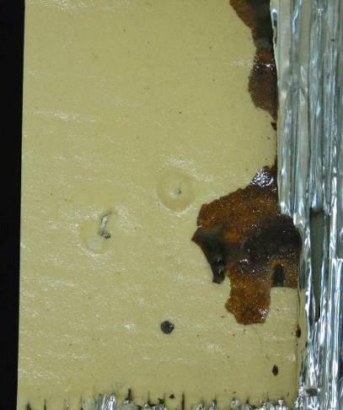 (a) 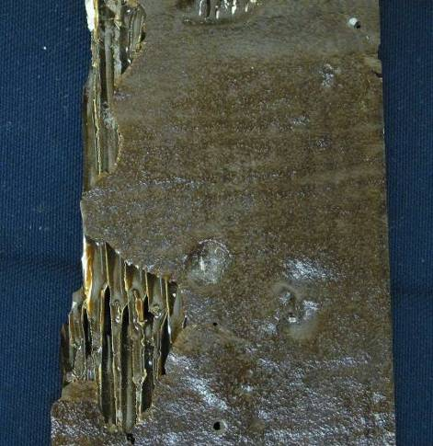 (b)
Figure 14 (a.) The surface of a production void on an F-111 rudder and (b) The injected adhesive that failed to bond to the slick surface created by the void.
For service defects, the use of injection repairs may also be a flight safety issue. Figure 15 shows a region of an F-111 over-wing fairing which had been subjected to injection repairs to correct a service defect. Note that the injected adhesive clearly replicates the surface of the old adhesive layer, demonstrating that adhesion to that layer had never occurred. Note also that there had been a second attempt to inject adhesive after the first attempt had failed. This component also failed in flight causing significant damage to the aft structure of the aircraft as the component departed in flight. Again, the size of the defect greatly exceeded the tolerable defect size determined for this component, yet the injection repair was considered terminating action for this defect and the component was returned to service.
The occurrence of service defects in adhesive bonds is a strong indication of underlying issues such as interfacial degradation or disbonding due to micro-voiding. Neither of these conditions is amenable to injection repairs, and to implement such repairs actually exacerbates the underlying problem by providing a short path for moisture ingress which will compound the problem even further by increasing the rate of interfacial hydration.
The only valid application of this technology is to cases where the total size of all production voids is smaller than the size determined by DTA, and then the only outcome is to hide the defect so that in-service inspection does not repeatedly report that defect. These repairs will NOT restore strength. If the total size of the void size exceeds the tolerable defect size as determined by DTA, then the component should be scrapped or repaired by a more rigorous method.
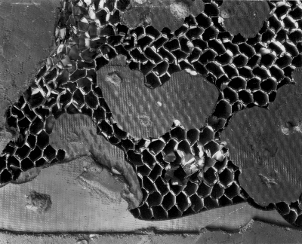
Figure 15. An injection repair of an F-111 over-wing fairing.
Outside of the specific case of macro-voids which are smaller than the tolerable defect size, injection repairs should be totally prohibited, as was undertaken by RAAF []. Injection repairs have no place in aircraft repair manuals.
CONCLUSIONS
Because the only adhesive bond defect to which DTA is applicable is macro-voiding, DTA is only of use in assessing the significance of post-production voids.
Attempts to repair macro-voids by injection methods are futile, and for voids which exceed the tolerable defect size such a repair may be a risk to flight safety.
DTA is not an appropriate method for managing continuing airworthiness of bonded structures which exhibit defects that occur in later service because:
- Defects which appear in service are either due to micro-void cohesion failure or due to adhesion or mixed-mode failure,
- NDI can only find these defects after disbonding has initiated,
- The material surrounding the defect will often not exhibit full bond strength, thus negating the conclusions in relation to critical defect sizes derived from certification testing based on artificial defects, and
- There is no method for prediction of damage growth rates against either time or flight hours.
One reliable defence against adhesion failures and mixed-mode failures is to prevent the occurrence of these conditions at the time the bond is produced in either production or repair. This requires validation of the resistance to hydration of surfaces prepared by the proposed production methods for surface preparation and heating.
One reliable defence against failure of micro-voided structures is more reliable definition of the environmental constraints during production to minimise moisture absorption during materials acceptance, handling, storage and use.
Apart from production repairs to voids smaller than the size determined by DTA, injection repairs for large production voids or in-service disbonds should be totally prohibited.
The irony is that if adhesion and mixed-mode failures and micro-voiding are eliminated and injection repairs are limited to non-significant production defects, then the only service damage which requires inspection would be due to accidental damage such as ground handling or bird impact. There would be no need for perpetual inspections for service disbonds because they should never happen. The impact of such a reduction of bond failures on the cost of ownership of bonded structures and consequent flight safety would be significant.
Guidance on development of durable adhesively bonded structures could be greatly enhanced by a simple amendment to FAR 2x.605 to require that adhesive bonding processes produce durable structures.

Contact address PO Box 265 Redbank 4301 Australia or email: max at adhesionassociates dot com.
Common practice is to designate interfacial failure of a bond in the adjectival form “adhesive” to describe interfacial failure and “cohesive” to designate fracture through the adhesive layer. This risks confusion between the terms “adhesive failure” i.e. failure of the adhesive material, which is termed “cohesive” failure and “adhesive failure” being interfacial failure. In order to more clearly distinguish the forms of failure, the author advocates the use of the words “adhesion” for interfacial failure and “cohesion” for fracture of the adhesive. This terminology has been adopted in FAA Advisory Circular AC 20-107B.
The discussion here relates specifically to metallic surfaces. Although a similar mechanism may exist for composite components, that aspect is not advocated in this paper.
Credit is acknowledged for name of the mythical country “Gybrobia” to William J. (Billy) Connelly.
Kinlock, A.J., Adhesion and Adhesives, p 78, Chapman and Hall, 1987.
Arnott, D.R., Wilson, A.R., Pearce, P.J., Mathys, G., Kindermann, M.R., Camilleri, A., DAVIS, M.J., Swan, G., Void Development in Aerospace Film Adhesives During Vacuum Bag Cure, Int. Aerospace Congress, Sydney, 25-28 Feb. 1997.
Pearce, P.J., Arnott, D.R., Camilleri, A., Kinderman, M.R., Mathys, G.I. and Wilson, A., Cause and Effect of Void Formation During Vacuum Bag Curing of Epoxy Film Adhesives, J. Adhesion Sci. Technol., Vol 12, No. 6, pp 567-584 (1998).
Davis, M.J. , Managing Micro-Voiding of Adhesive Bonds, http://www.adhesionassociates.com/papers/Managing%20Micro-Voiding%20of%20Adhesive%20Bonds.pdf
Nitowski, G.A., Topographic and Surface Chemical Aspects of the Adhesion of Structural Epoxy Resins to Phosphorus Oxo Acid Treated Aluminum Adherends, PhD Dissertation submitted to the Faculty of the Virginia Polytechnic Institute and State University, August 26, 1998, Blacksburg, Virginia
Frankland, S. J. V., Clancy T. C., , Hinkley J. A., Gates, T. S., Molecular Dynamics Simulation of Adhesion at Epoxy Interfaces, American Society for Composites, Memphis, TN, Sept 8-11, 2008.
Davis, M.J. and M^{c}Gregor, A., Assessing Adhesive Bond Failures: Mixed-Mode Bond Failures Explained, Presented at ISASI Australian Safety Seminar, Canberra, 4-6 June 2010.
Romeyn, A., Engineered System Failure Analysis Report: Main Rotor Blade Fracture Robinson R22, VH-OHA, OCCURRENCE 200302820, 2 Nov. 2005, Appendix B, Items 48 and 49.
Davis, M.J. and Tomblin, J, Best Practice in Adhesive Bonded Structures and Repairs, DOT/FAA/AR – TN06/57, Apr 2007.
Bowditch, M.R., The Durability of Adhesive Joints in the Presence of Water, Int. J. Adhesion and Adhesives 16 (1996) pp 73-79 dated 14 Dec 1996.
Tomblin, J and Davies, C, Bonded Structures Industry Survey, Seattle WA, 11-22 June 2004.
Cheng, L., PS-ACE100-2005-10038, Bonded Joints and Structures - Technical Issues and Certification Considerations, 02 September 2005.
Davis, M.J., Deficiencies in Regulations for Certification and Continuing Airworthiness of Bonded Structures, International Aerospace Congress, Sydney, 25-27 February 1997.
Davis, M.J., Practical Application Technology for Adhesive Bonded Repairs, Advances in the Bonded Composite Repair of Metallic Aircraft Structures, Baker, A.A. Jones, R., Ed's., Chapter 24, Matinus Nijhoff publishers, 2000.
Butkus, Lt. Col. L., Residual Strength of Bonded Repairs After 10 Years of Service, Aircraft Structural Integrity Program Conference, 30 Nov 2006.
Certification of Adhesive Bonded Structures, Final Report of The Technical Cooperation Program (TTCP) Action Group 13, February 2001.
DEF (AUST) 9005, RAAF Standard on Composite Materials and Adhesive Bonded Repairs, 04 Sep 1995.

